**SRM UNIVERSITY**

**DEPARTMENT OF MATHEMATICS**

**UNIT II VECTOR CALCULUS**

***PART A***

***MULTIPLE CHOICE QUESTIONS***

1. The directional derivative of 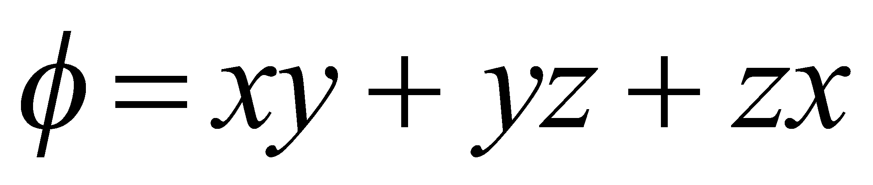 at the point (1,2,3) along x- axis is

a) 4 b) 5 c) 6 d) 0

1. In what direction from (3, 1, -2) is the directional derivative of 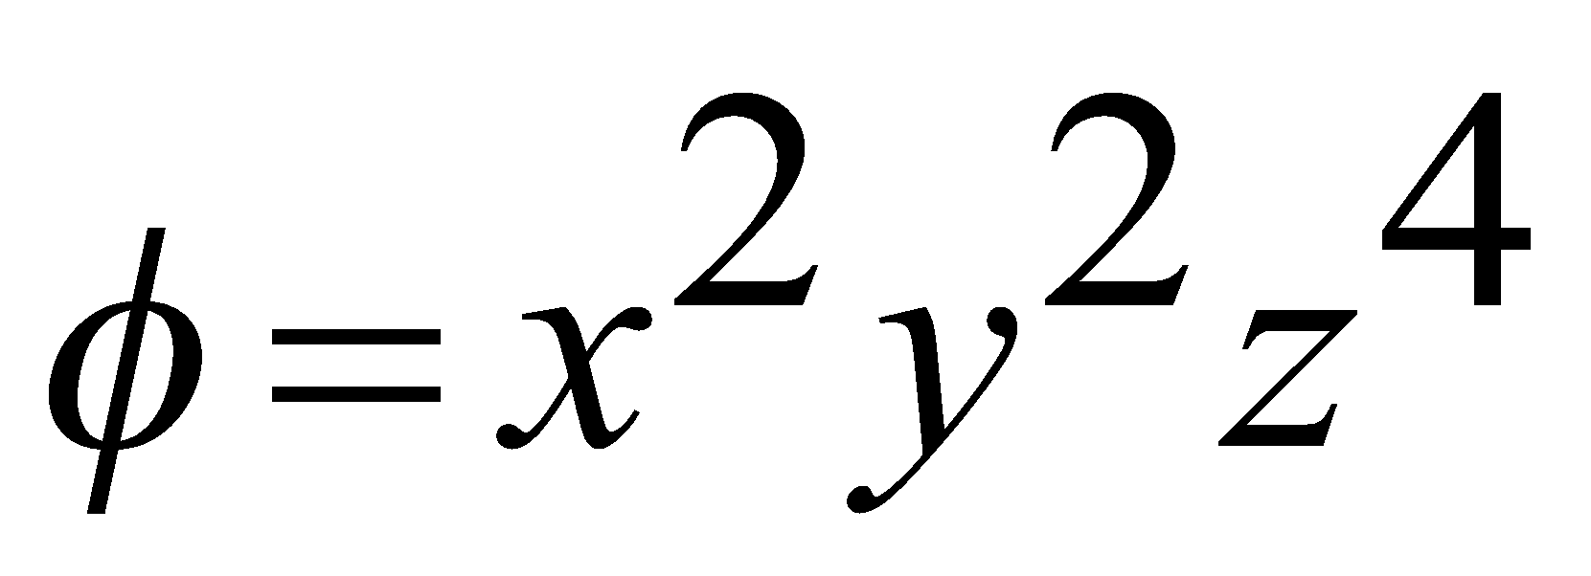maximum?

a) 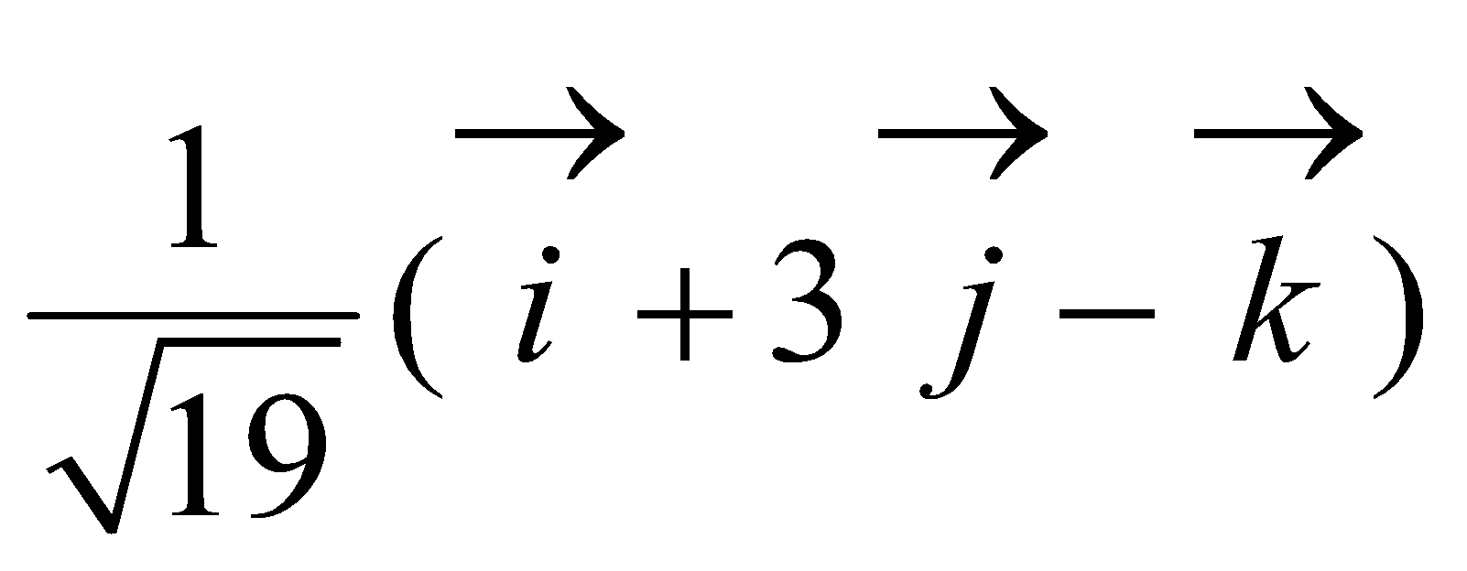 b) 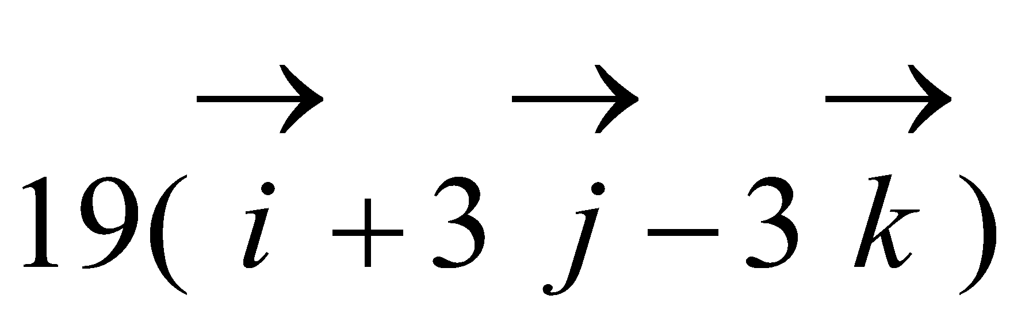

c) 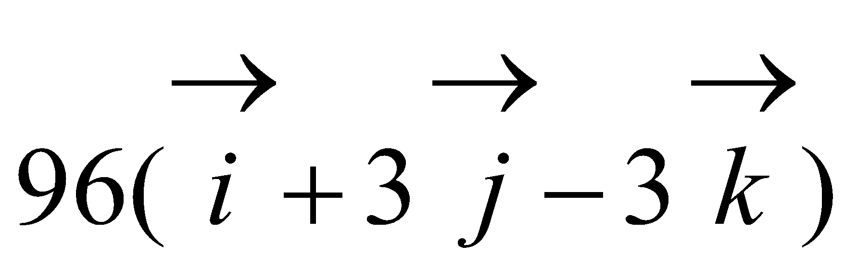 d) 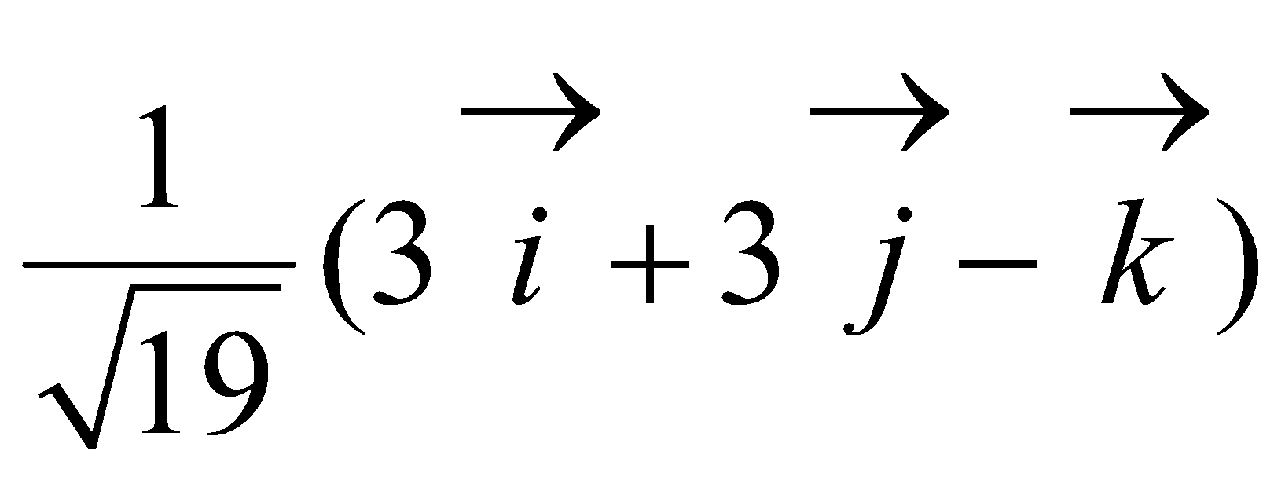

1. If 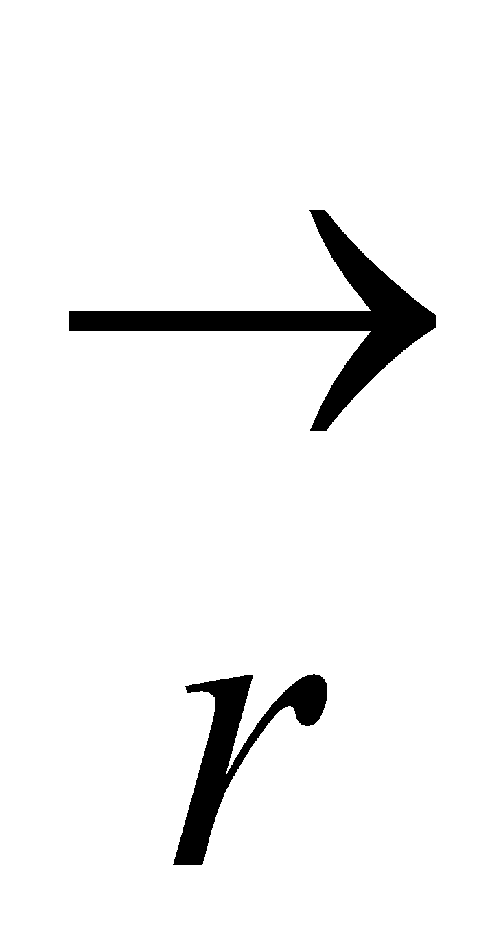is the position vector of the point (x, y, z) w.r.to the origin, then 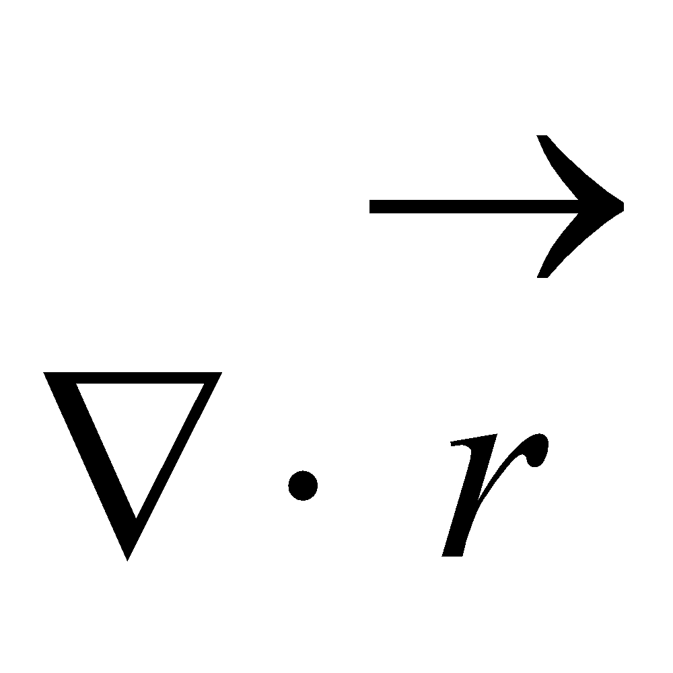 is

a) 2 b) 3 c) 0 d) 1

1. If is the position vector of the point (x, y, z) w.r.to the origin, then 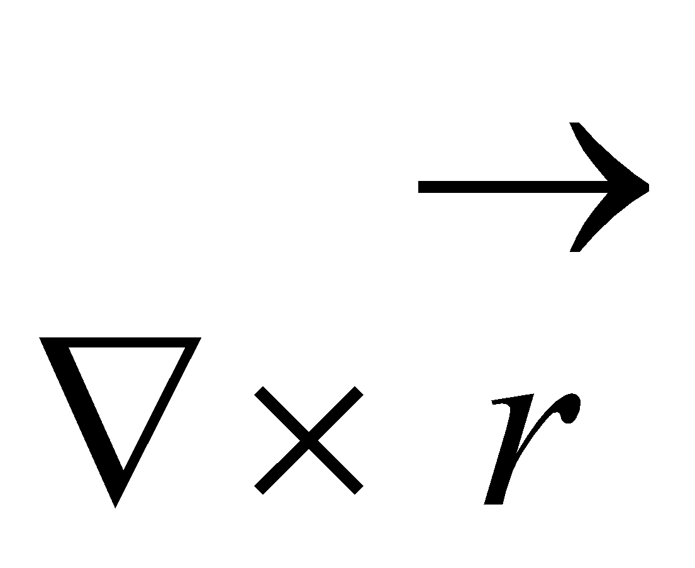 is

a) 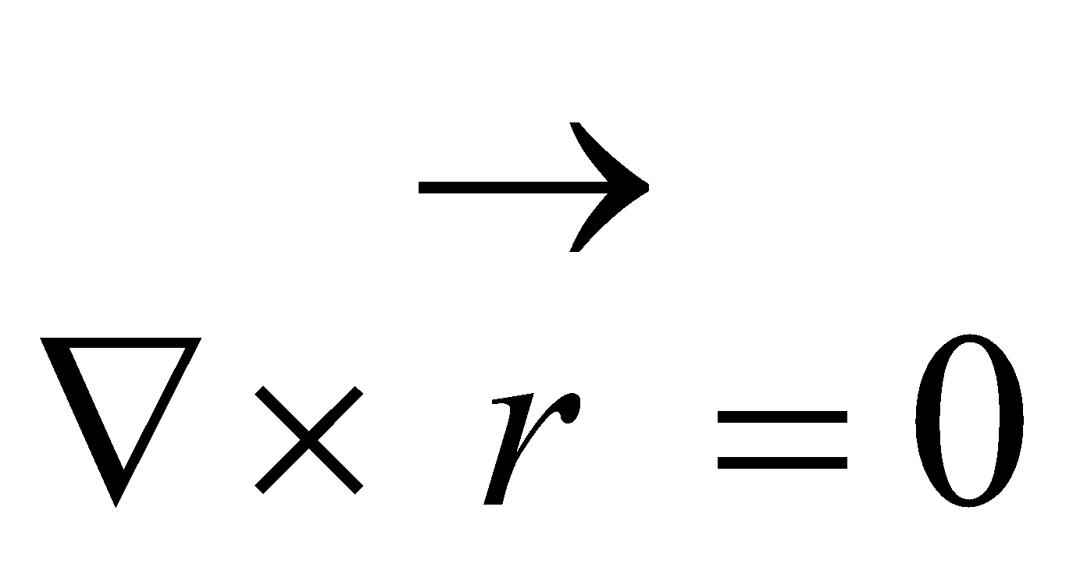 b) 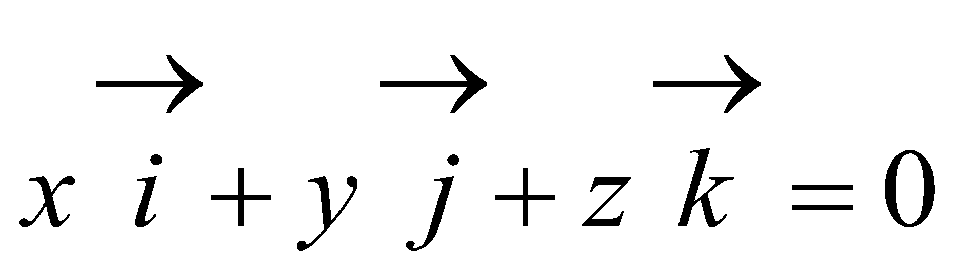 c) 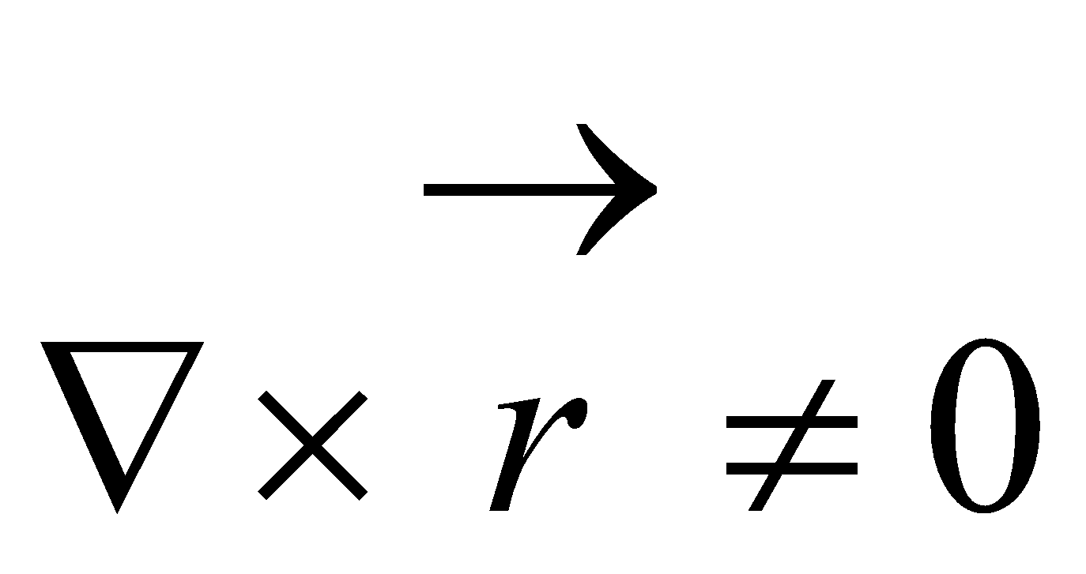 d) 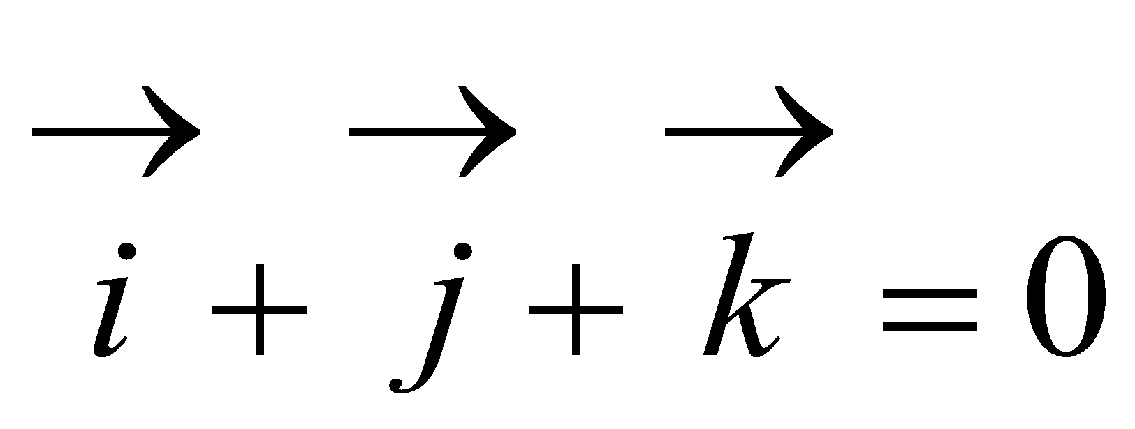

1. The unit vector normal to the surface 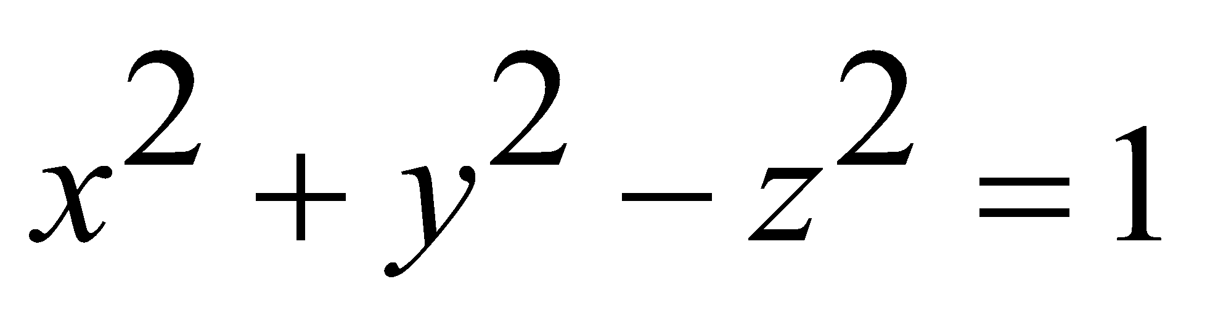 at (1,1,1,) is

a) 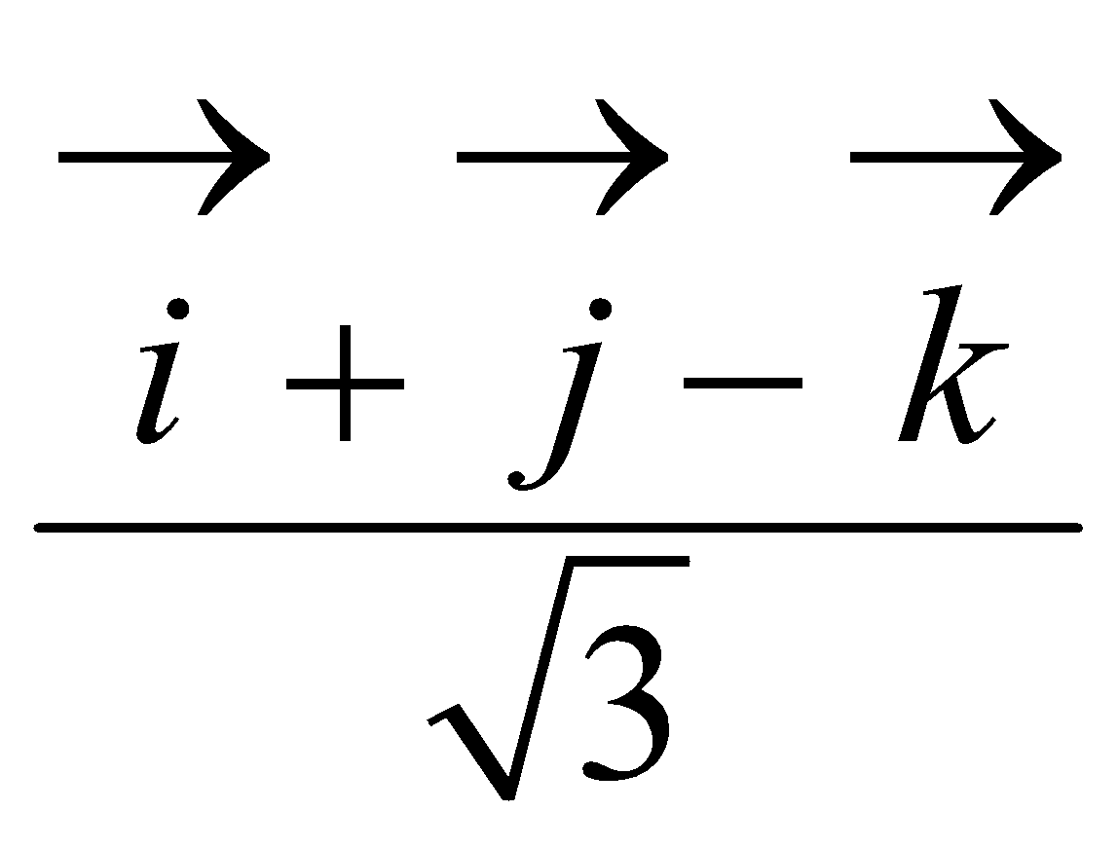 b) 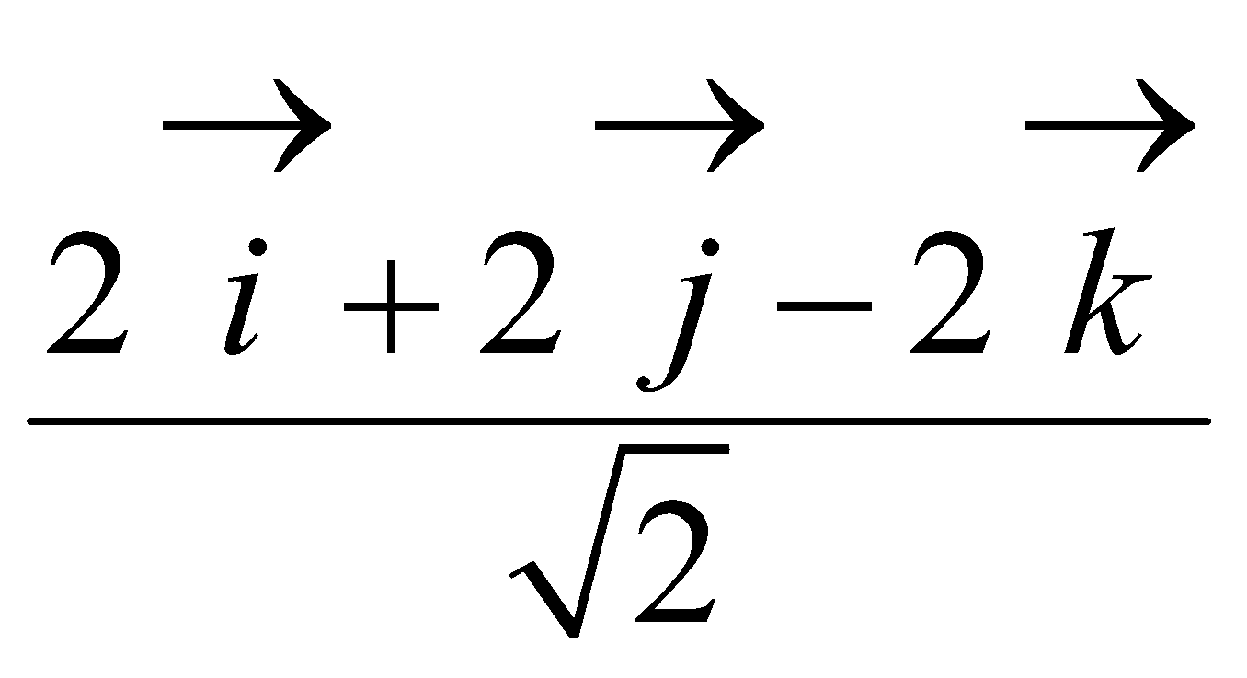 c) 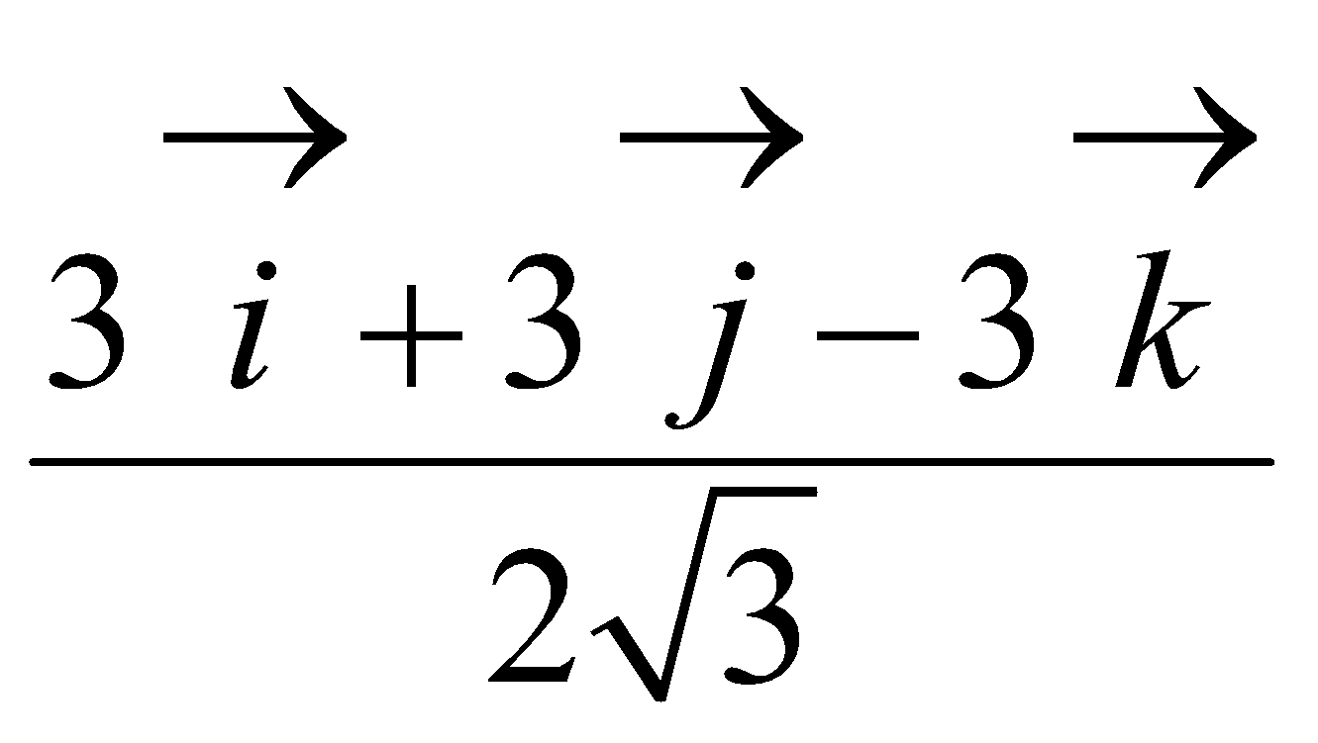 d) 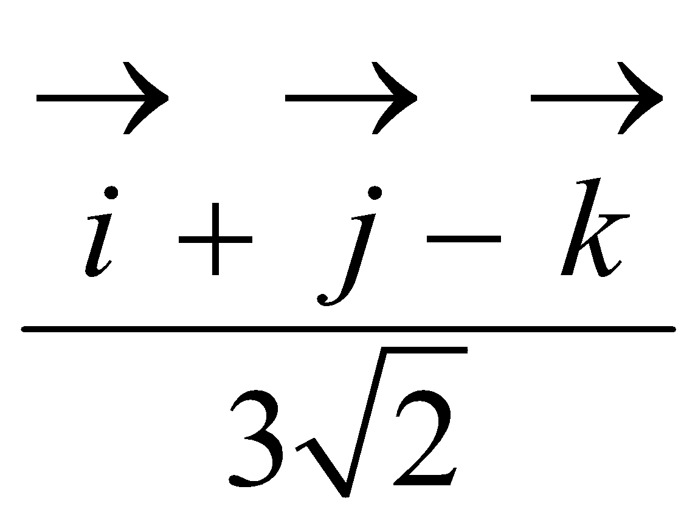

1. If 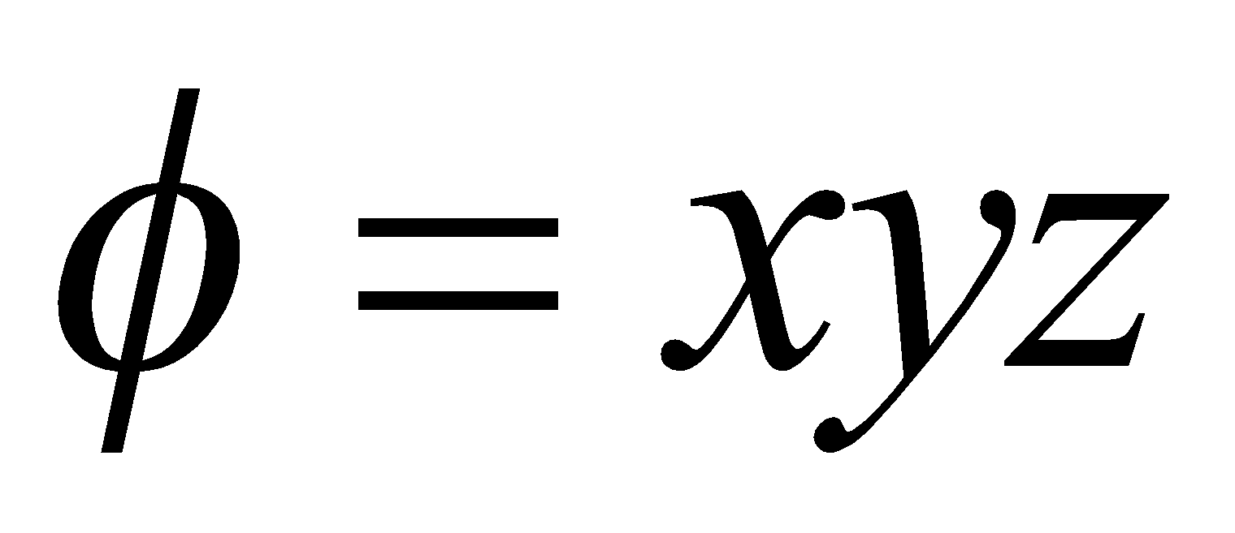,then 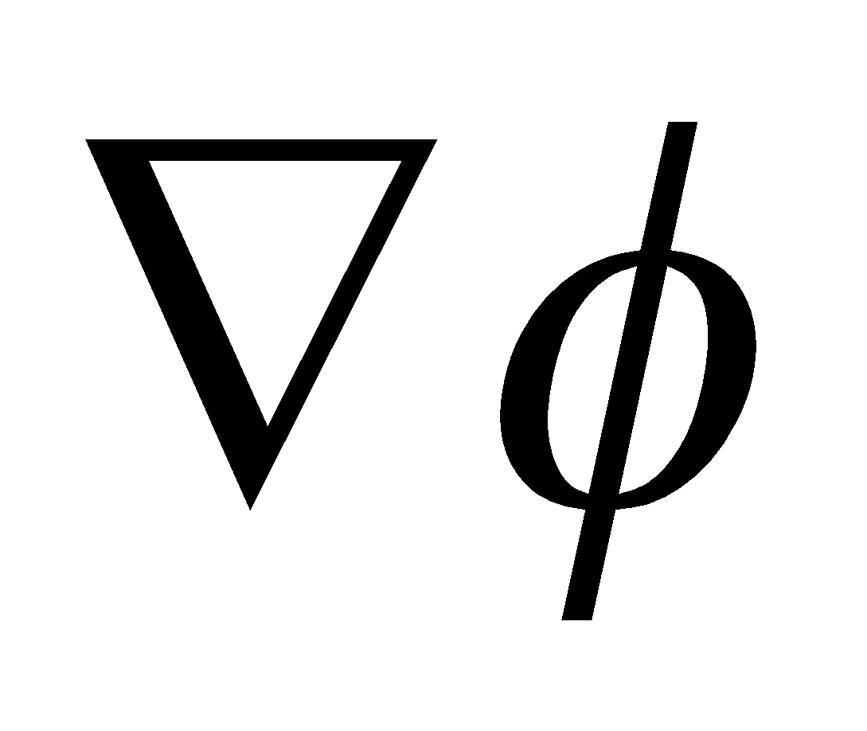 is

a) 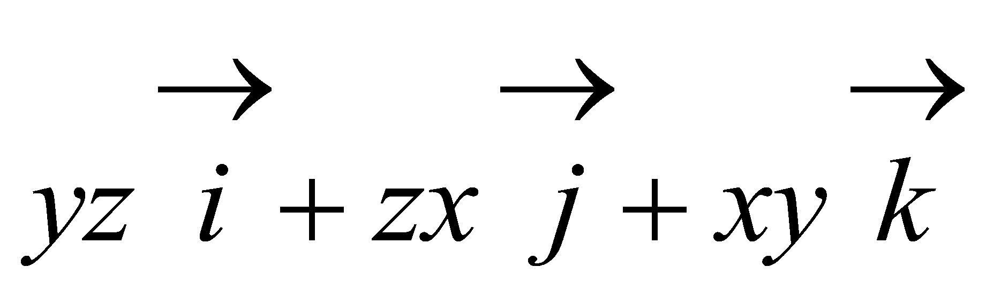 b) 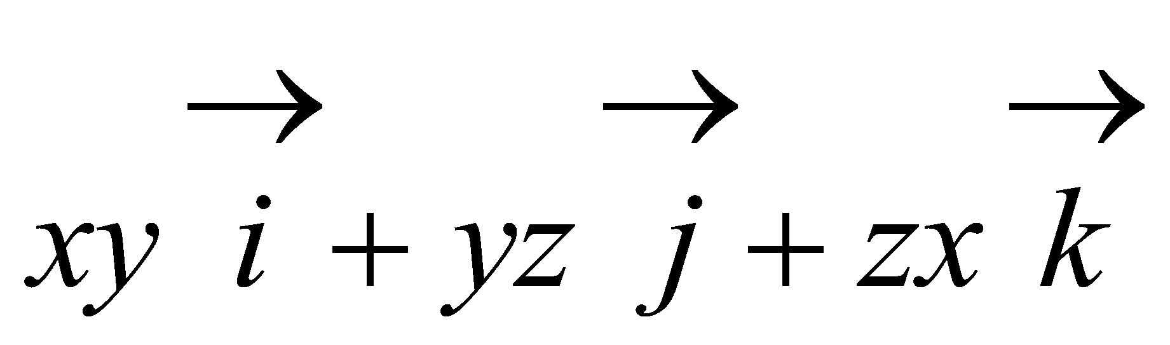 c) 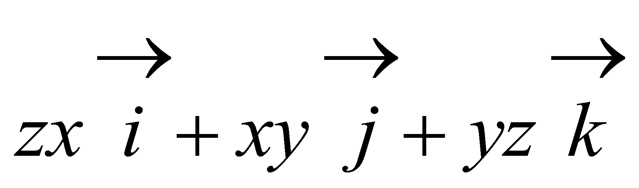 d) 0

1. If 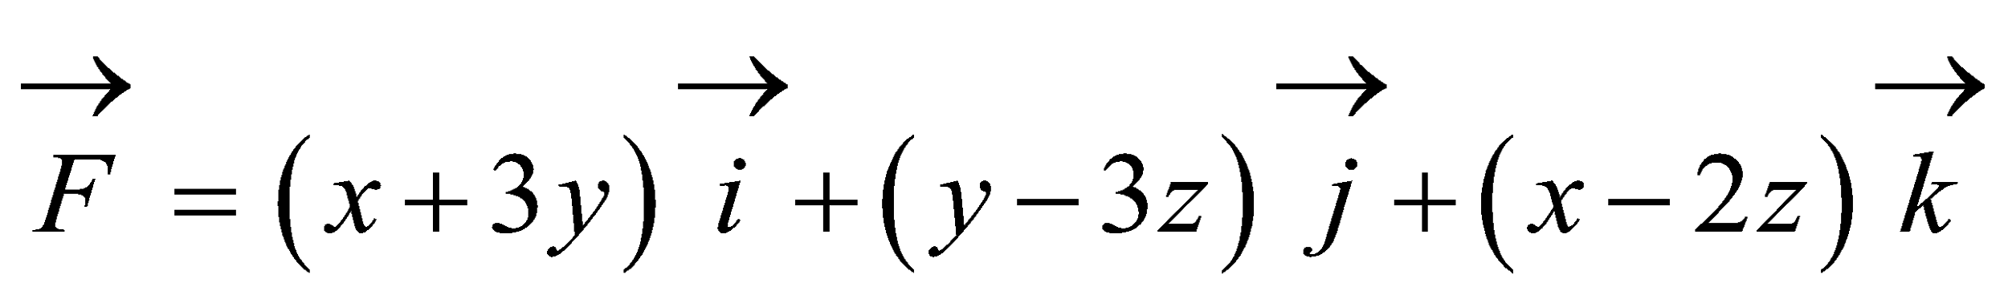 then 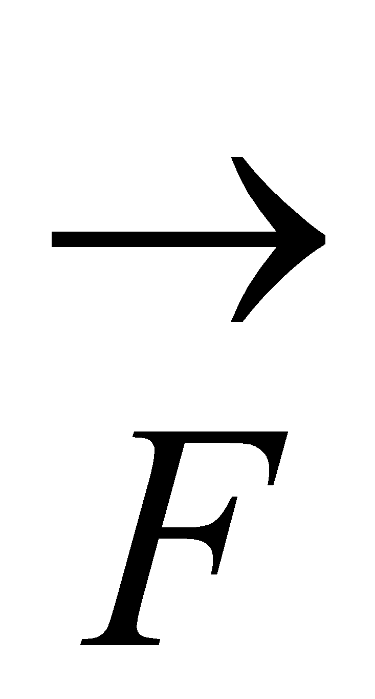 is

a) solenoidal b) irrotational c) constant vector d) both solenoidal

& irrotational

1. If 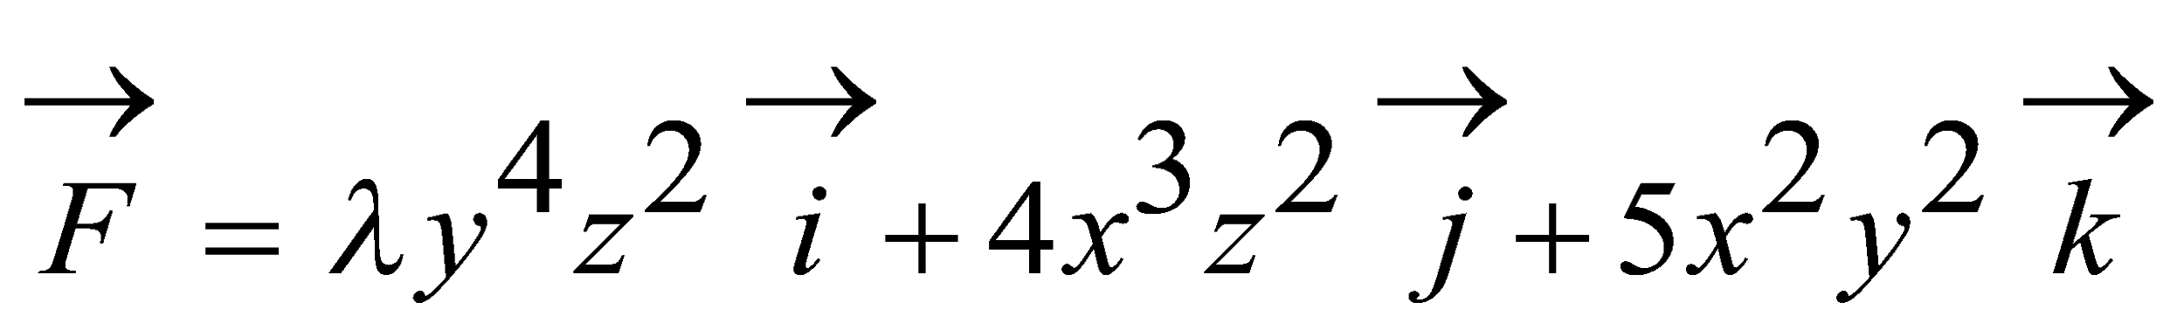 is a solenoidal , then the value of 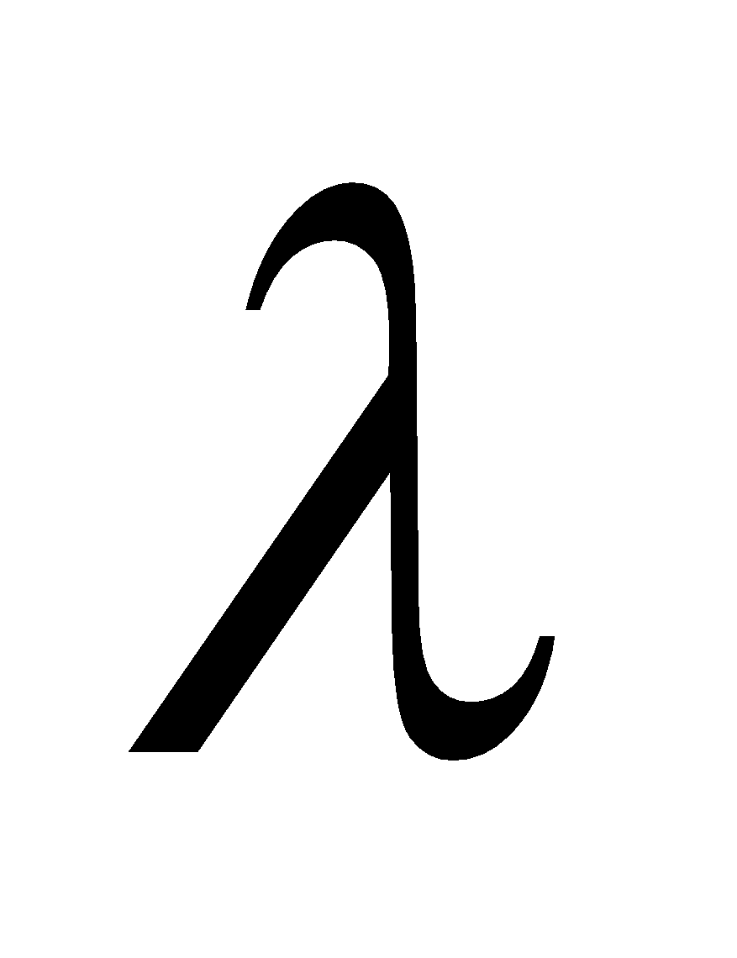 is

a) x b) -x c) any value d) 0

1. If 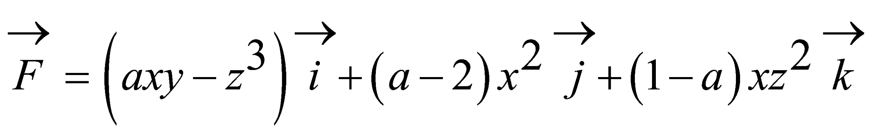is irrotational then the value of a

a) 0 b) 4 c) -1 d) 2

1. If 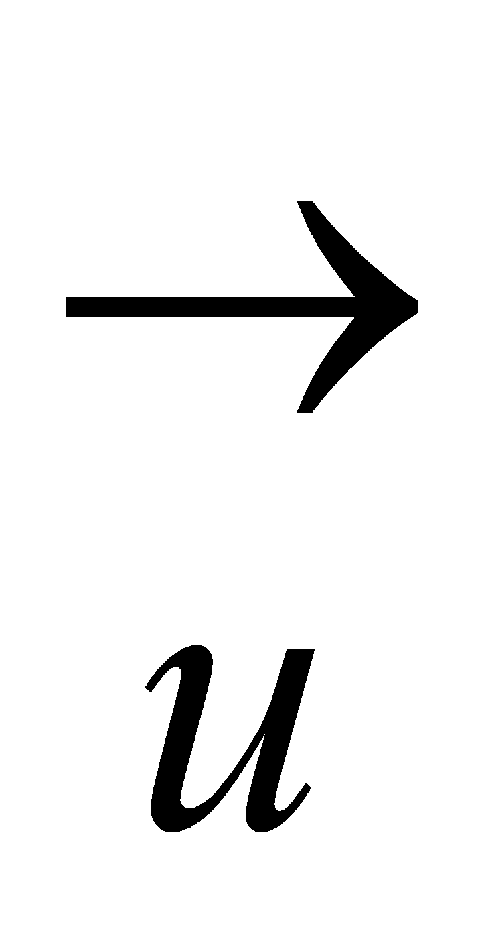 and 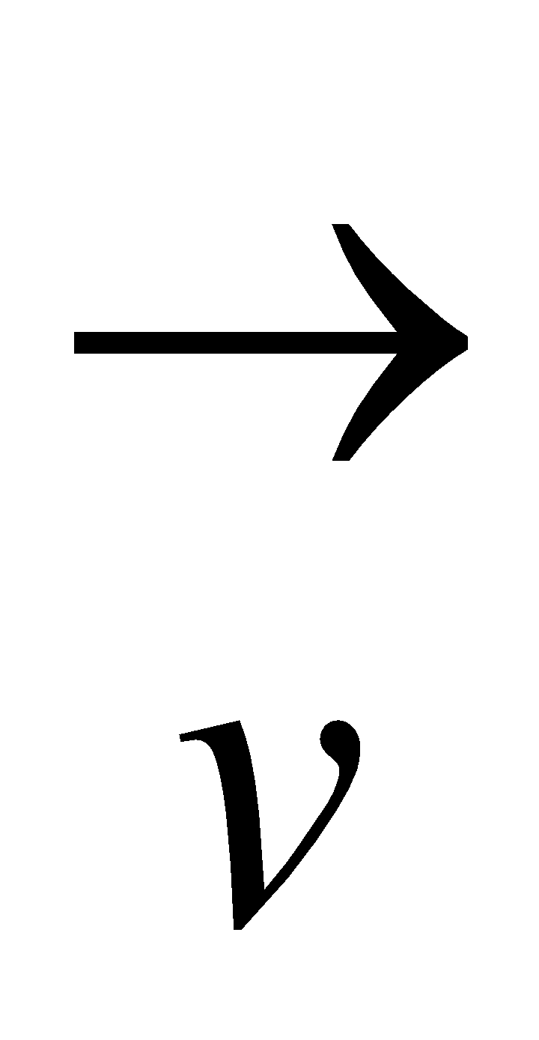 are irrotational then 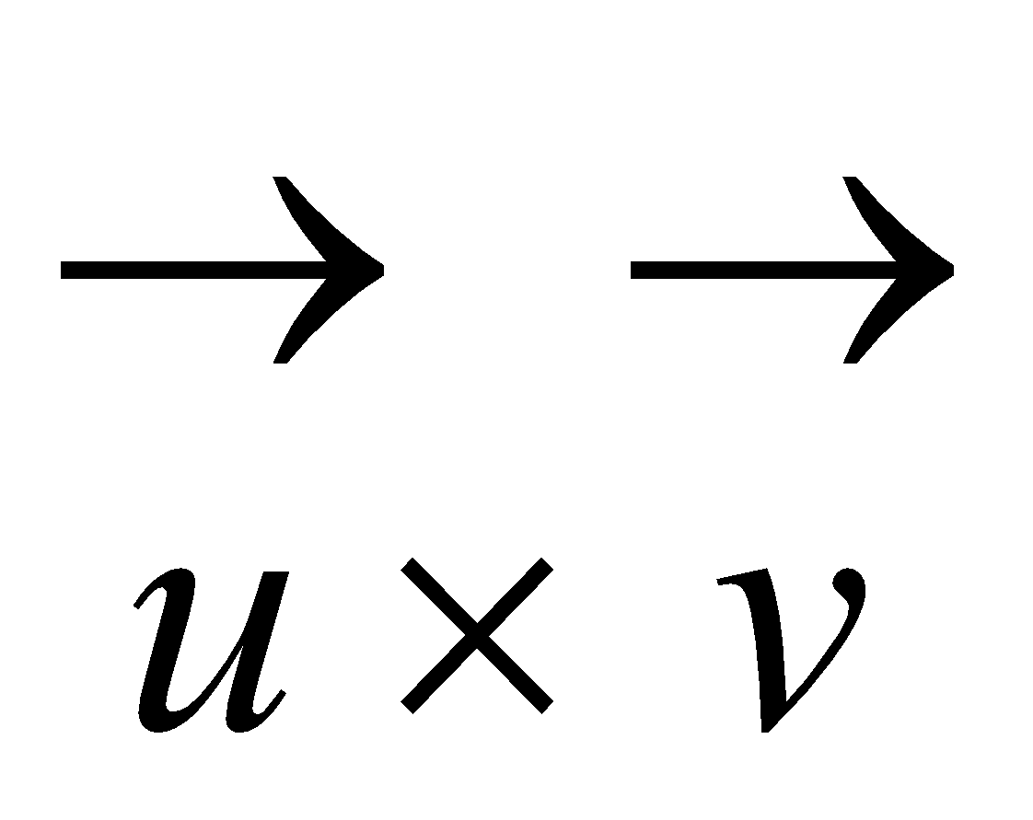 is

a) solenoidal b) irrotational c) constant vector d) zero vector

1. If 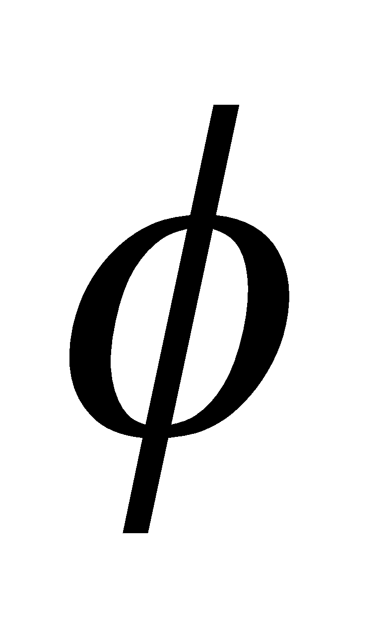 and 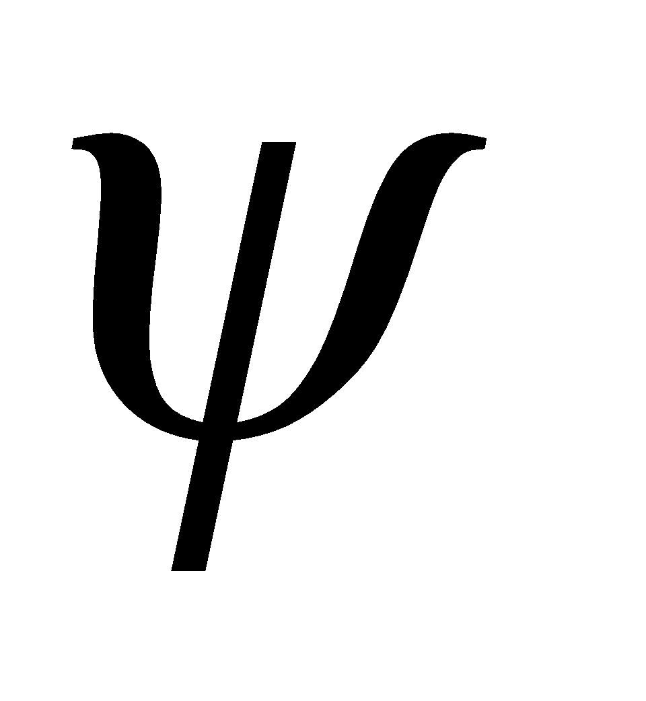 are scalar functions then 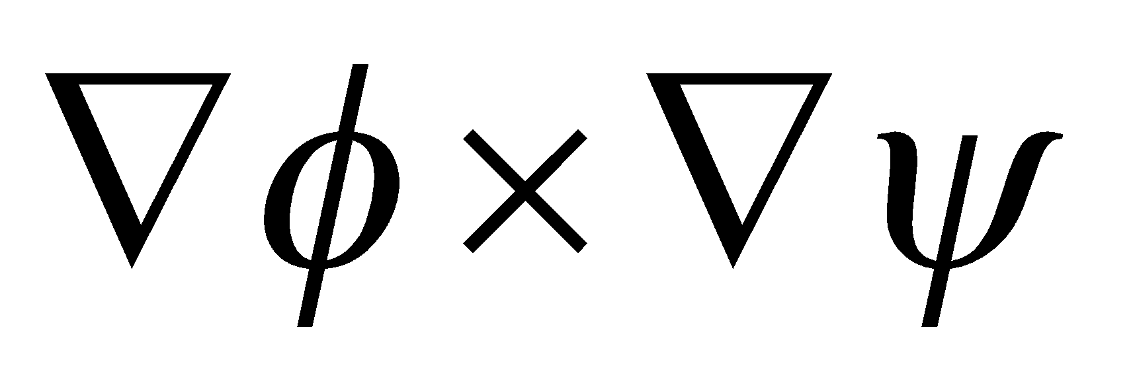 is

a) solenoidal b) irrotational c) constant vector d) both solenoidal

& irrotational

1. If 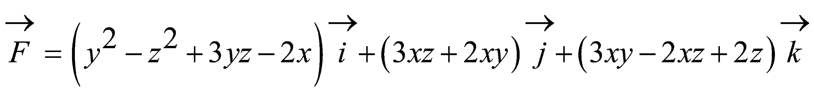 then is

a) solenoidal b) irrotational c) both solenoidal & ) irrotational

d) neither solenoidal nor irrotational

1. If 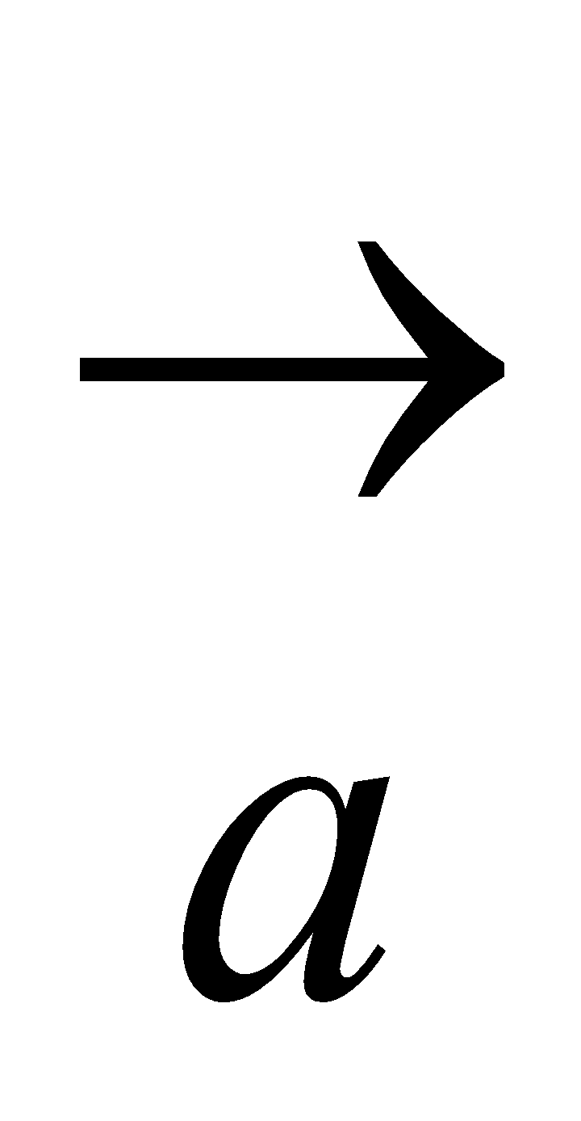is a constant vector and  is the position vector of the point (x,y,z) w.r.to the

Origin then 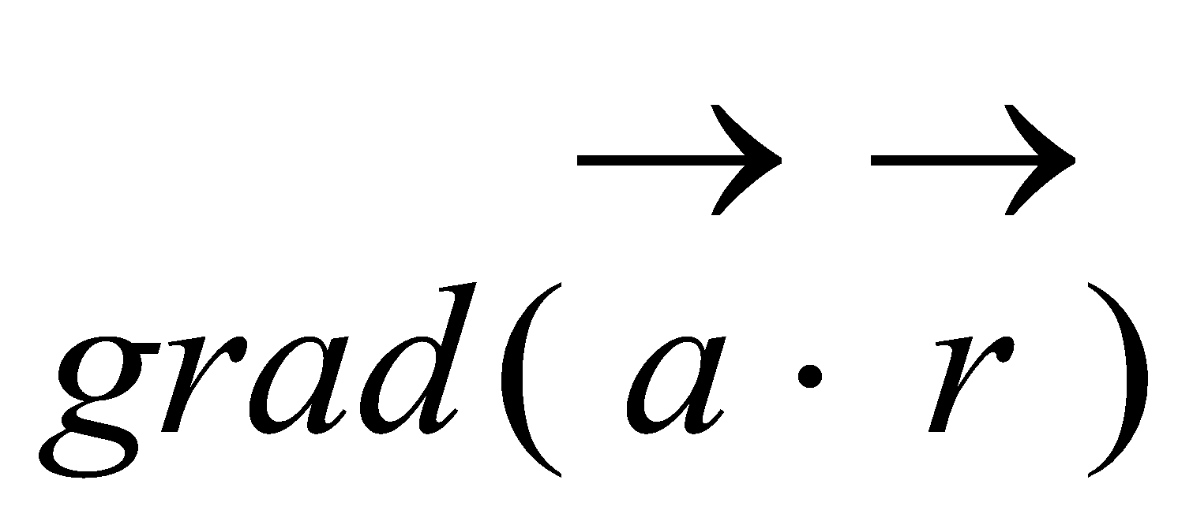 is

a) 0 b) 1 c)  d) 

1. If is a constant vector and  is the position vector of the point (x, y, z) w.r.to

the origin then 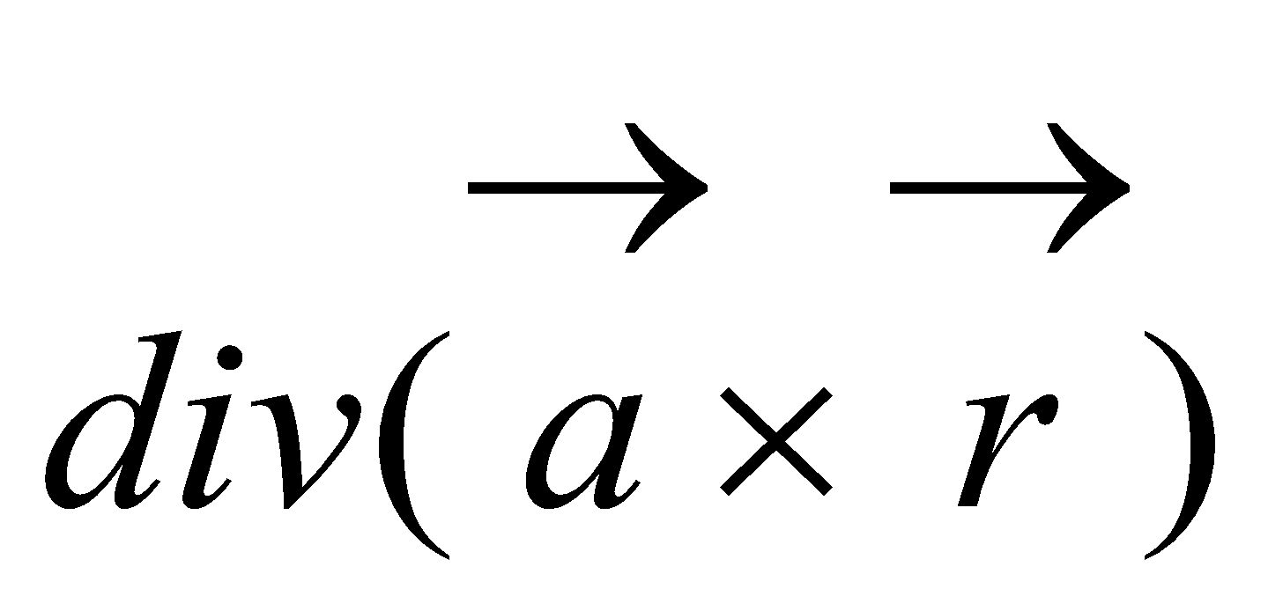 is

a) 0 b) 1 c)  d) 

1. If is a constant vector and  is the position vector of the point (x,y,z) w.r.to

the origin then 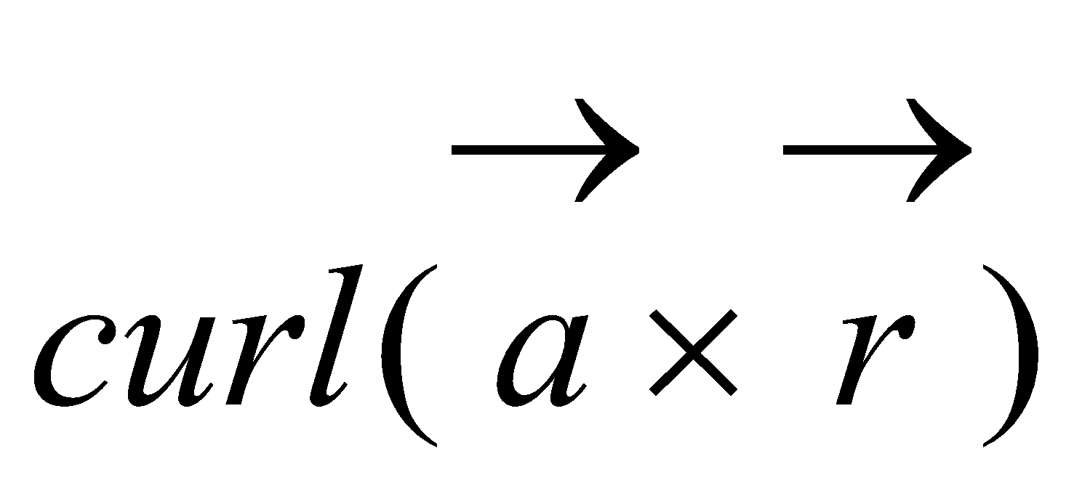 is

a) 0 b) 1 c) 2 d) 2 

1. If  scalar functions then 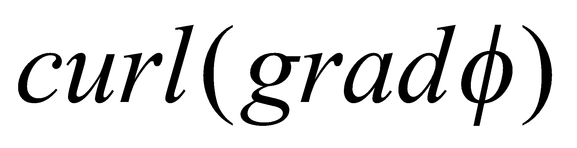 is

a) solenoidal b) irrotational c) constant vector d) 0

1. If the value of 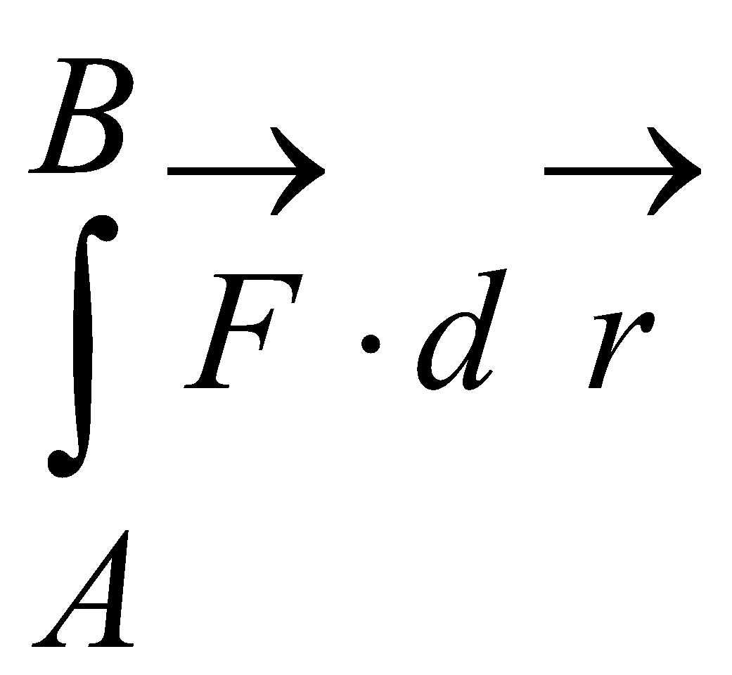 does not depend on the curve C ,but only on the terminal

points A and B then  is called

a) solenoidal vector b) irrotational vector c) conservative vector

d) neither conservative nor irrotational

1. The condition for  to be Conservative is ,should be

a) solenoidal vector b) irrotational vector c) rotational

d) neither solenoidal nor irrotational

1. The value of 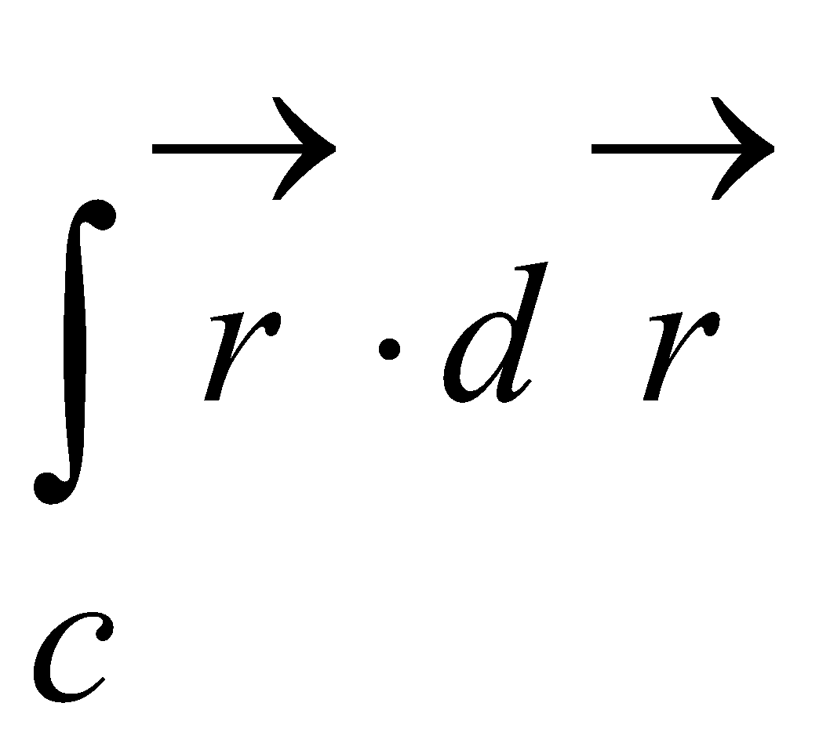 where C is the line 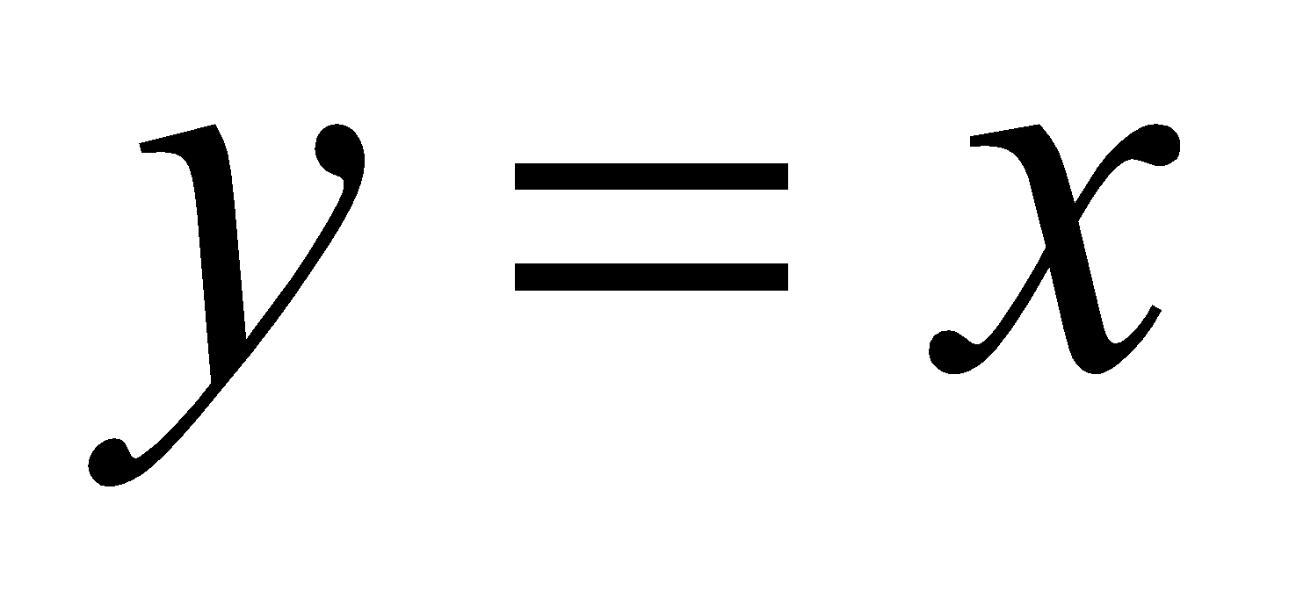 in the 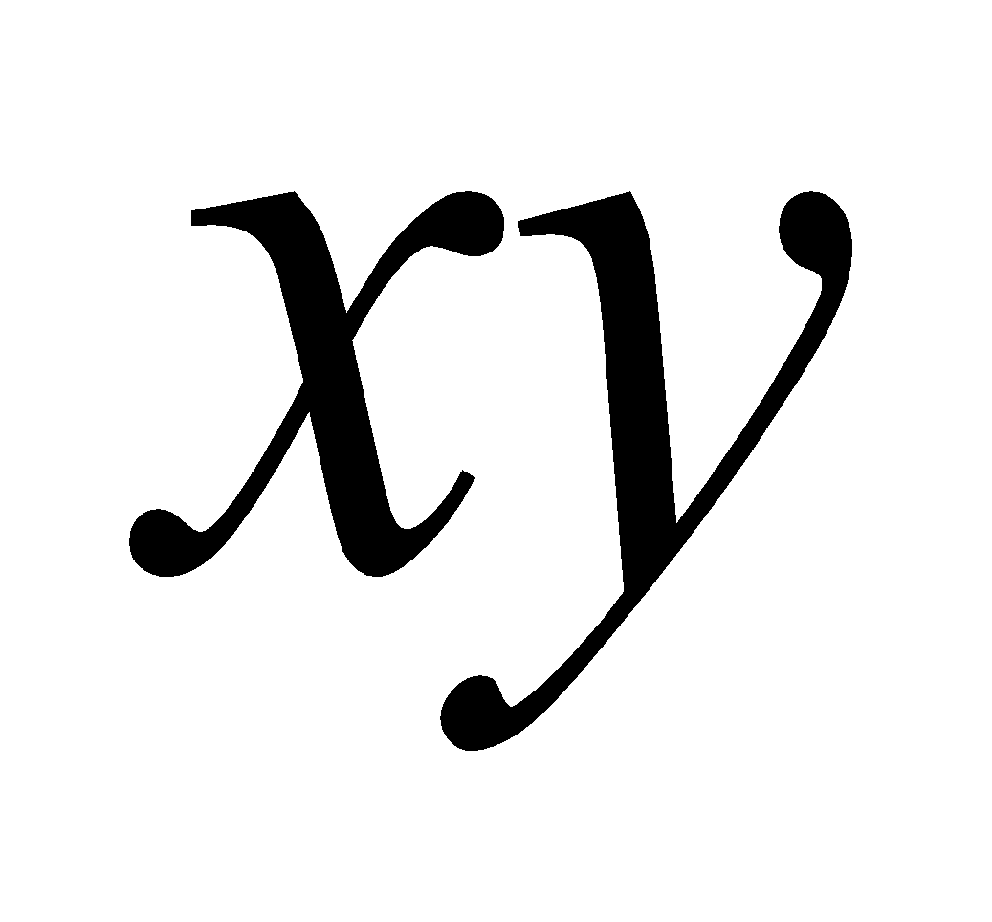-plane from (1,1) to (2,2) is

a) 0 b) 1 c) 2 d) 3

1. The work done by the conservative force when it moves a particle around a closed curve is

a) 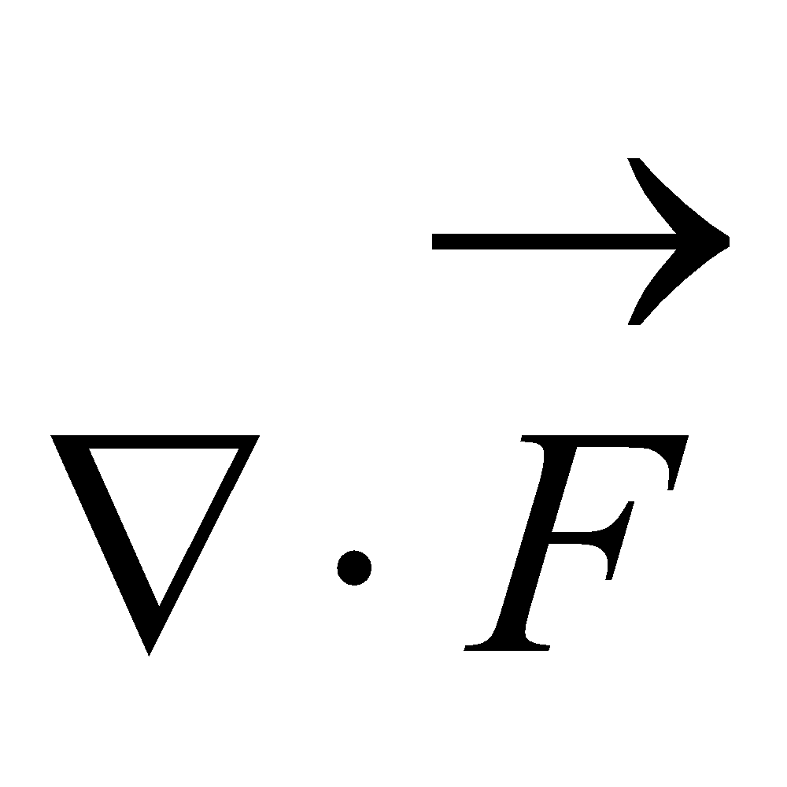=0 b) 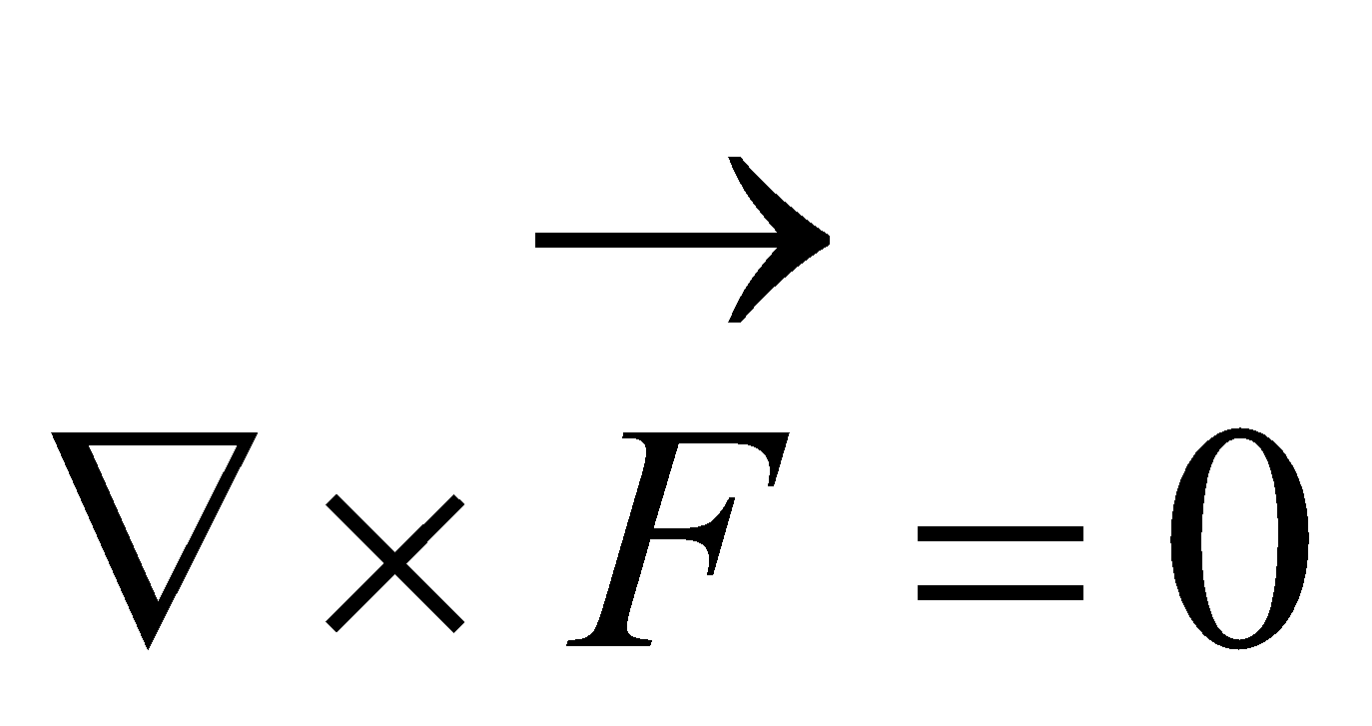 c ) 0 d) 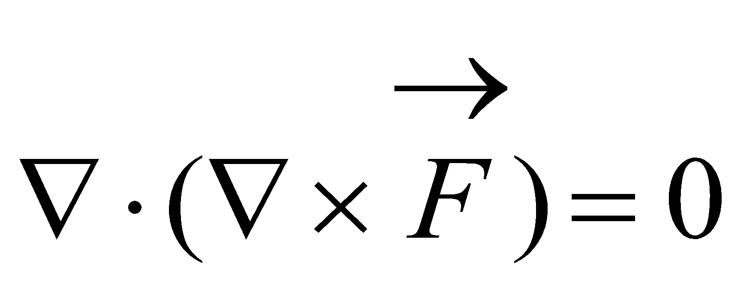

1. The connection between a line integral and a double integral is known as

a) Green’s theorem b) Stoke’s theorem c) Gauss Divergence theorem d) convolution theorem

1. The connection between a line integral and a surface integral is known as

a) Green’s theorem b) Stoke’s theorem c) Gauss Divergence theorem

d) Residue theorem

1. The connection between a surface integral and a volume integral is known as

a) Green’s theorem b) Stoke’s theorem c) Gauss Divergence theorem

d) Cauchy’s theorem

1. Using Gauss divergence theorem ,find the value of 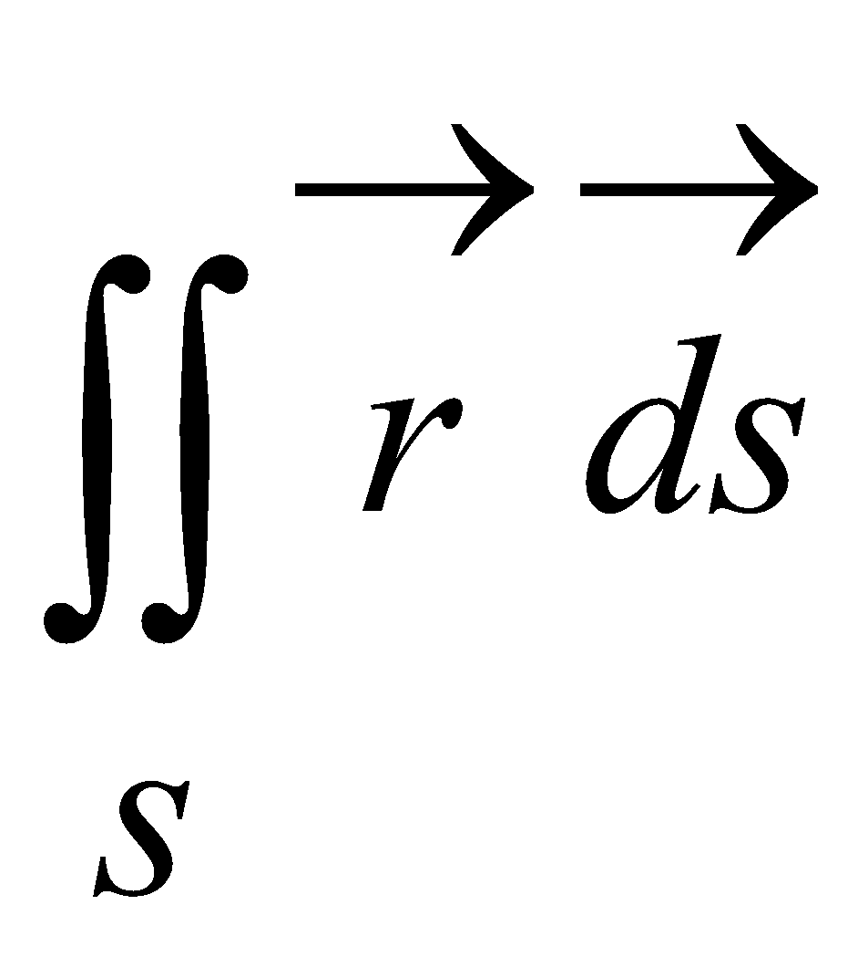 where is the position vector and V is the volume

a) 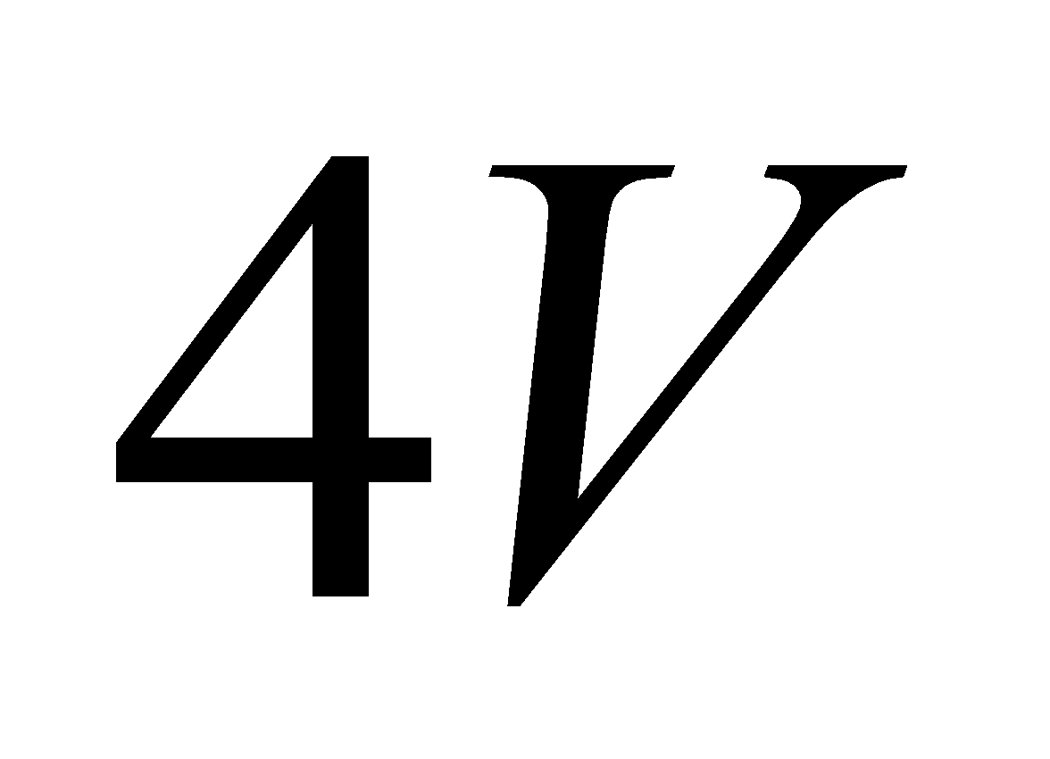 b) 0 c) 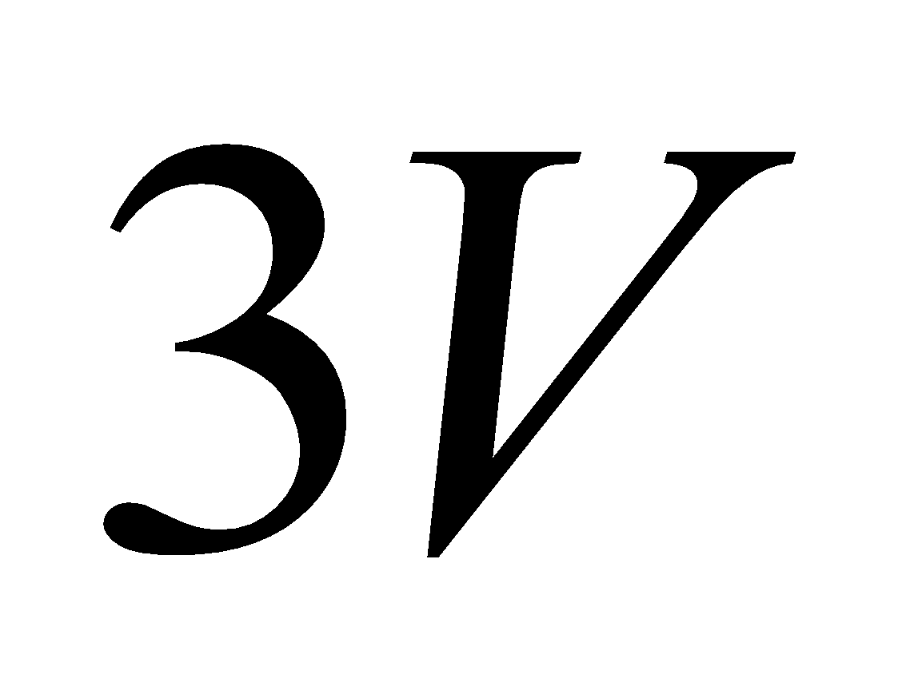 d) volume of the given surface

1. If S is any closed surface enclosing the volume V and if 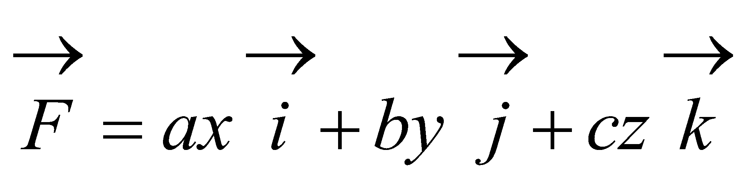 then the

value of 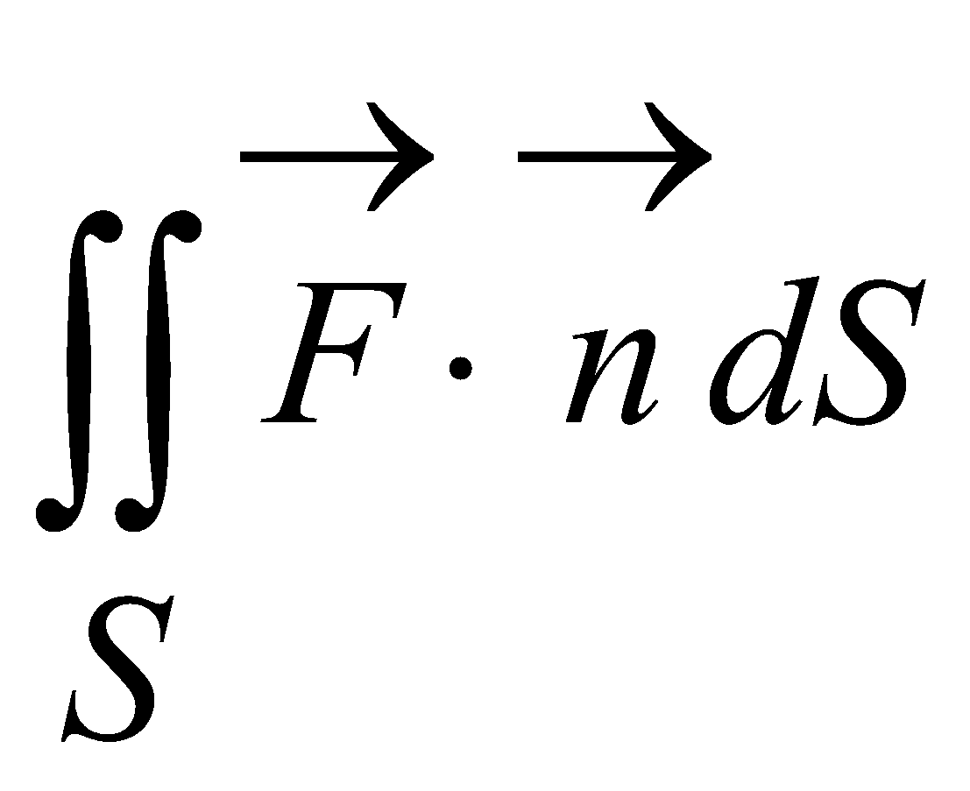 is

a) 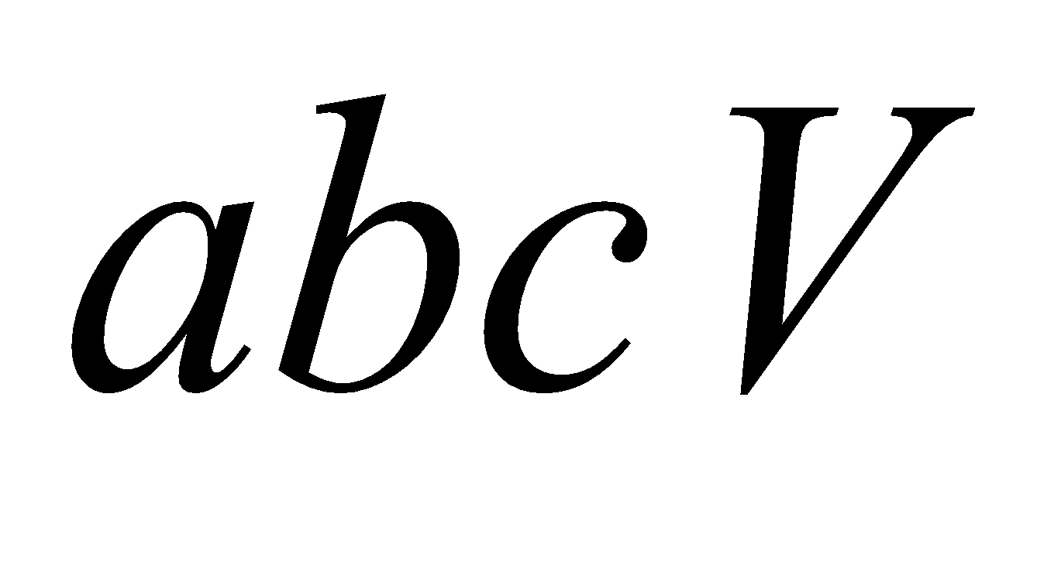 b) 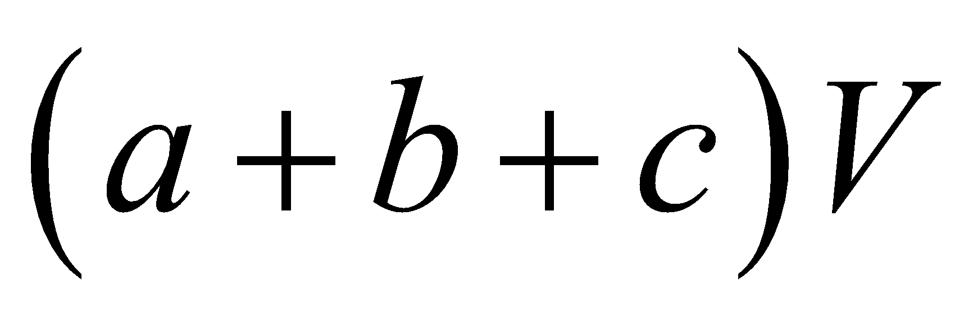 c) 0 d) 